**EXPERIMENT-12**

**DATE;01-10-2025**

**AIM;** Demonstrate virtualization by Installing Type-2 Hypervisor in your device, create and configure VM image with a Host Operating system (Either Windows/Linux) using virtual box.

**PROCEDURE;**

**STEP 1;** Install VirtualBox (Type-2 Hypervisor) on your device.

**STEP 2;** Open VirtualBox and click New to create a VM.

**STEP 3;** Enter the VM name, OS type, and version.

**STEP 4;** Allocate RAM size for the VM.

**STEP 5;** Create a Virtual Hard Disk and set storage size.

**STEP 6;** Attach the OS ISO file under VM settings.

**STEP 7;** Start the VM and install the Guest Operating System.

**IMPLEMENTATION;**

**OUTPUT;**

**STEP 1;** Install VirtualBox (Type-2 Hypervisor) on your device.

**STEP 2;** Open VirtualBox and click New to create a VM.

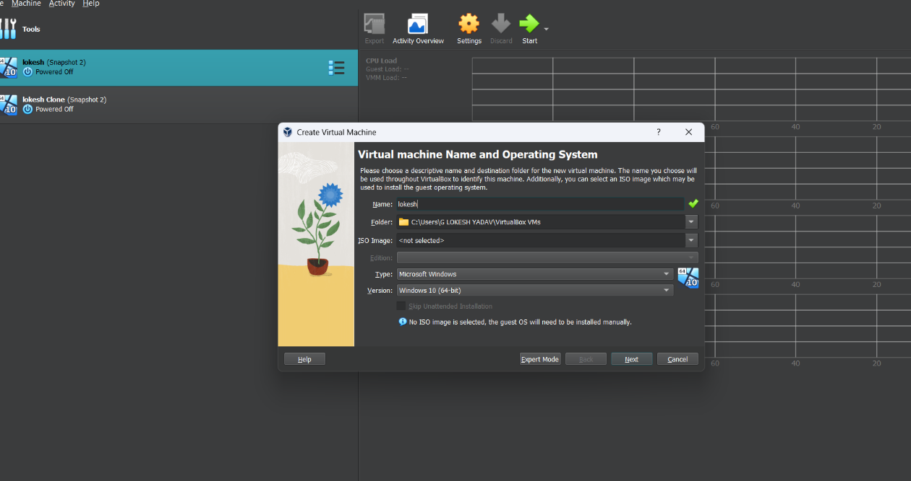

**STEP 3;** Enter the VM name, OS type, and version.

**STEP 4;** Allocate RAM size for the VM.

**STEP 5;** Create a Virtual Hard Disk and set storage size.

**STEP 6;** Attach the OS ISO file under VM settings.

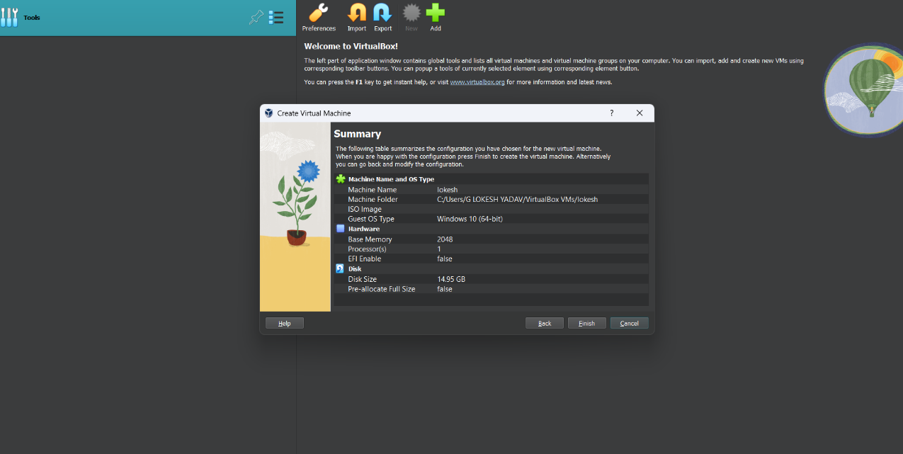

**STEP 7;** Start the VM and install the Guest Operating System.

**RESULTS;** Successfully Demonstrated virtualization by Installing Type-2 Hypervisor in My device, created and configured VM image with a Host Operating system (Either Windows/Linux) using virtual box.